# Deals And Coupons Finder App – Low-Level Design (LLD)

**Objective:**

The Deals and Coupons Finder project helps users discover the best promotional offers and discount coupons based on brand and category. It includes role-based access, Unidays-inspired working to enhance the shopping experience with personalized and efficient deal recommendations. Admins can manage coupon inventory, while users enjoy a seamless and intuitive experience.

**Architecture Overview:**

The Deals and Coupons Finder App follows a microservices-based architecture using Spring Boot. It comprises several microservices, an API Gateway, and a Eureka Server for service registration and discovery.

**Microservices Involved**

1. **API Gateway**
2. **Discovery Server (Eureka)**
3. **Profile Service**
4. **Inventory Service**
5. **Payment Service**

**1. API Gateway**

- Technology: Spring Cloud Gateway

## - Responsibilities

- Routing client requests to appropriate services

- Handling JWT-based authentication

- Managing cross-cutting concerns (e.g., security)

**2. Eureka Server**

- Technology: Netflix Eureka

## - Responsibilities

- Service registration and discovery

- Monitoring service’s health

**3. Profile Microservice**

- Technology: Spring Boot

## - Routes

- `/auth/login` () - Login with credentials

- `/auth/signup` () - Signup

-`/auth/profile` () - feign-client route

## - Responsibilities

- Authentication, Registration

**4. Inventory Microservice**

- Technology: Spring Boot

## - Admin Coupon Routes

- `/inventory/coupon/add/promotional` (POST) - Add promotional coupon

- `/inventory/coupon/add/paid` (POST) - Add paid coupon

- `/inventory/coupon/update` (PUT) - update coupon

- `/inventory/coupon/delete/{id}` (DELETE) – delete coupon by id

- `/inventory/coupon/delete-expired` (DELETE) – delete coupon if expiry date has passed

## - Public Coupon Routes

- `/inventory/coupon/all` (GET) – get all coupon

- `/inventory/coupon/get/{id}` (GET) – get coupon by id

- `/inventory/coupon/get/brand/{brand}` (GET) – get coupon by brand

-`/inventory/coupon/get/category/{category}` (GET) – get coupon by category

## - Admin Booking Routes

- `/inventory/booking/all` (GET) – get all bookings

## - User Booking Routes

- `/inventory/booking/promotional/{couponId} ` (GET) – get the promotional coupon

- `/inventory/booking/paid` (POST) – book the paid coupon

- `/inventory/booking/payment/{bookingId}` (GET) – pay for the coupon

- `/inventory/booking/user/{userId}` (GET) – get booking by userId

## - Responsibilities

- Managing Room and Inventory operations

**5. Billing and payment Microservice**

- Technology: Spring Boot

## - Routes

- `/bills/createbill` – Create a bill for a booking

- `/bills/success` – Handle successful payment via session ID

- `/bills/getByBookId/{bookId}` – Get bill details by booking ID

## - Responsibilities

- Bill management

## Flow Diagram

The following diagram illustrates the architecture and flow of communication between different services in the Deals and Coupons Finder App.

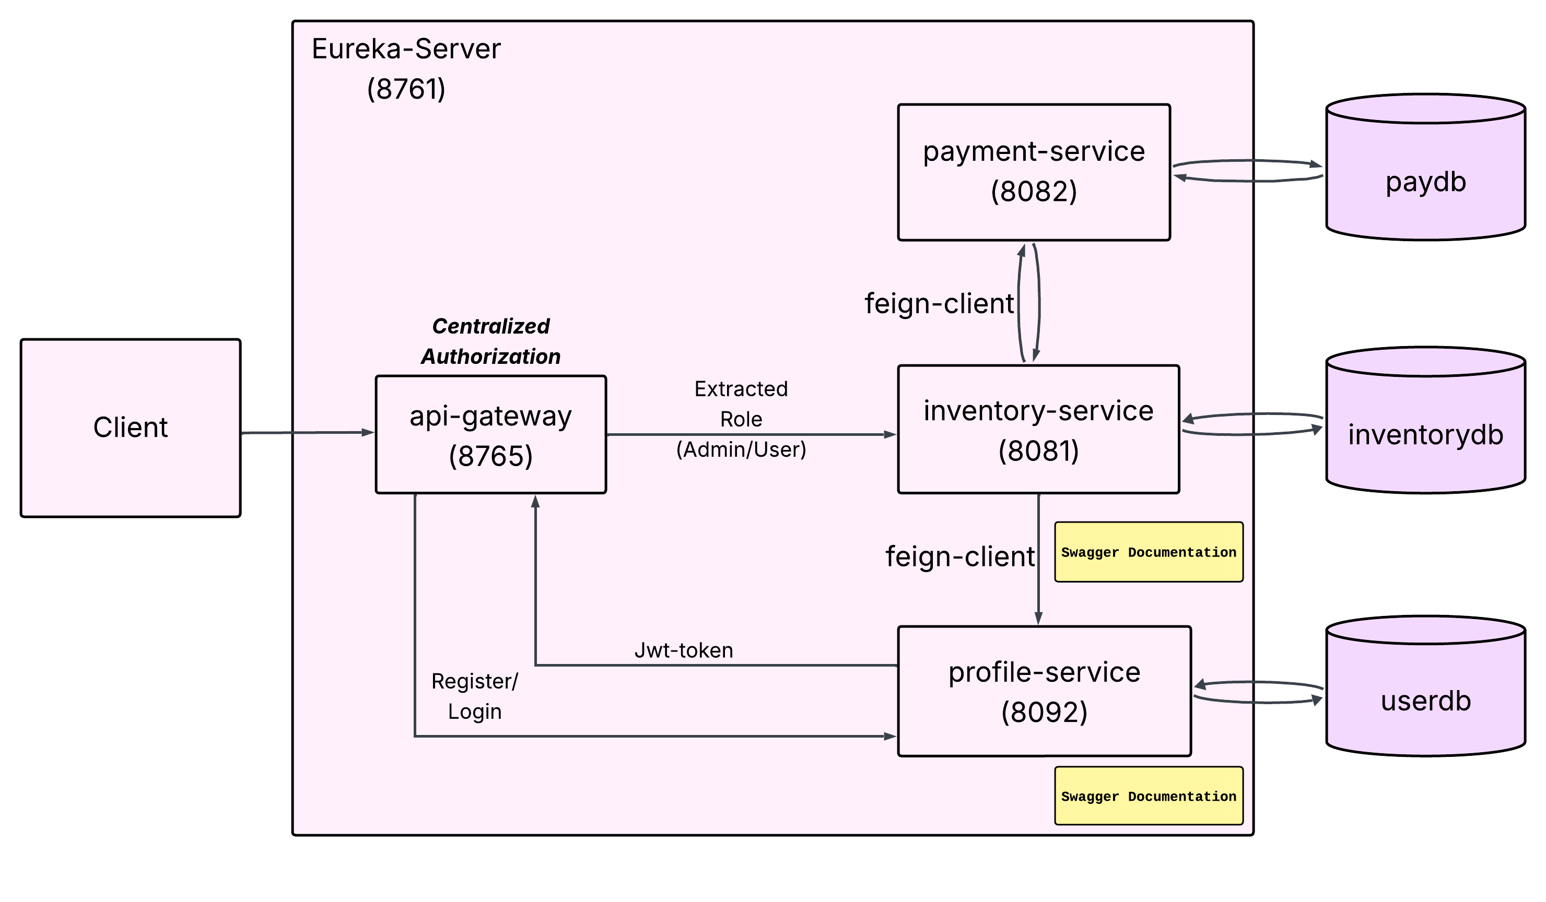

**ER Diagram:**

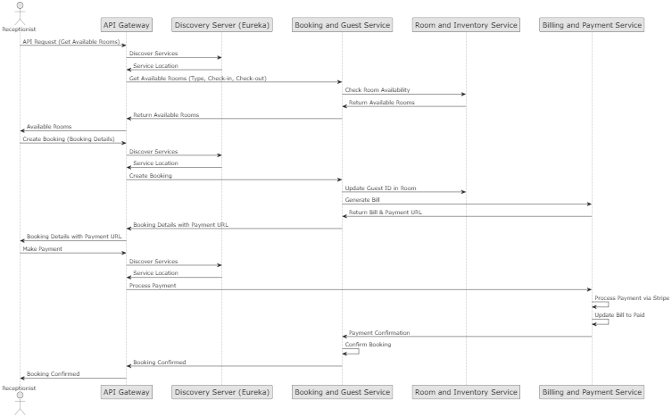

|  |  |  |  |
| --- | --- | --- | --- |
| **Step** | **Sender** | **Receiver** | **Description** |
| 1 | Admin/Manager/Receptionist | API Gateway | Sends HTTP POST /booking/addBooing request |
| 2 | API Gateway | Booking and Guest Service | Route the Create Booking and Guest |
| 3 | Booking and Guest  Service | Billing and Payment  Service | Create Bill using guest and inventory details and sending Payment URL |
| 4 | Billing and Payment Service | Booking and Guest Service | Returns Payment Url |
| 5 | Booking and Guest Service | API Gateway | Return Booking detail with payment Url |
| 6 |  | Api Gateway | Returns mock payment success/failure |
| 7 | Api gateway | Billing and Payment Service | Update Bill status |
| 8 | Billing Payment Service | Booking and Guest Service | Update the Booking status |
| 9 | Billing Payment Service | Api Gateway | Returns purchase success response |